

B.M.S College of Engineering Department of Computer Science and Engineering

**Supported by: Karnataka Fund for Infrastructure Strengthening in Science and Technology in Higher Educational Institutions (K-FIST L1/L2) K-FIST & VGST, Government of Karnataka GRD No: 963**

**Principal Investigator: Dr Kavitha Sooda Co-Principal Investigator: Dr Indiramma M Year of sanction: 2021**

**Infrastructural Development for Neurological Disorder using Brain Signal Computing**

**ANALYTICS TEAM**

*Abstract: The experiment performed is used to determine the effect of p-300 BCI based games on the cognitive functions of the dyslexic children.P300 is an event-related potential (ERP) that occurs when a subject detects a significant stimulus in the context of the task. It’s called P300 as a positive peak appears in the EEG in the region of 300 ms after its presentation. After pre-processing the obtained the EEG data, we analyse the effect of P-300 based games. The comparison will be done for the P300 Event Related Potential of the EEG data during the initial and the later stages of using the mobile application to determine the effect of cognitive functions.*

PROPOSED WORK FLOW

1. *Use an existing EEG dataset to identify the process/steps for pre-processing the EEG data.*
2. *After obtaining the EEG data collected from various subjects during the experiment, pre-process the EEG data with the help of the identified steps.*
3. *Train and test the model after the algorithm has been identified. This further helps us in the classification process.*

INTRODUCTION

INTRODUCTION

METHODOLOGY

*ERP(Event Related Potentials) measured by EEGs are the most effective non-invasive ways of measuring response of a very specific event(stimuli).Specifically P300 response is interpreted to reflect a higher cognitive response to an unexpected stimuli which reflects processing of information in dyslexic children. This analysis of ERPs are done on the dyslexic children to observe the improvement in cognitive functions of brain.*

*T*

FURTHER ACTIONS

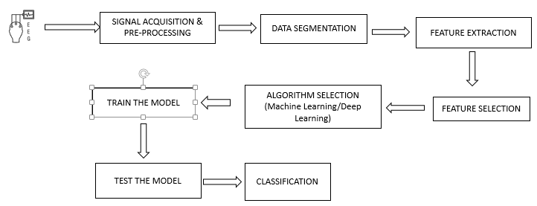

1. *Perform the necessary pre-processing on the EEG data to remove the unwanted noises and identify P300 wave.*
2. *With the help of P300 wave, the effect of cognitive functions are to be analysed initially and after using the mobile application developed for the dyslexic children.*

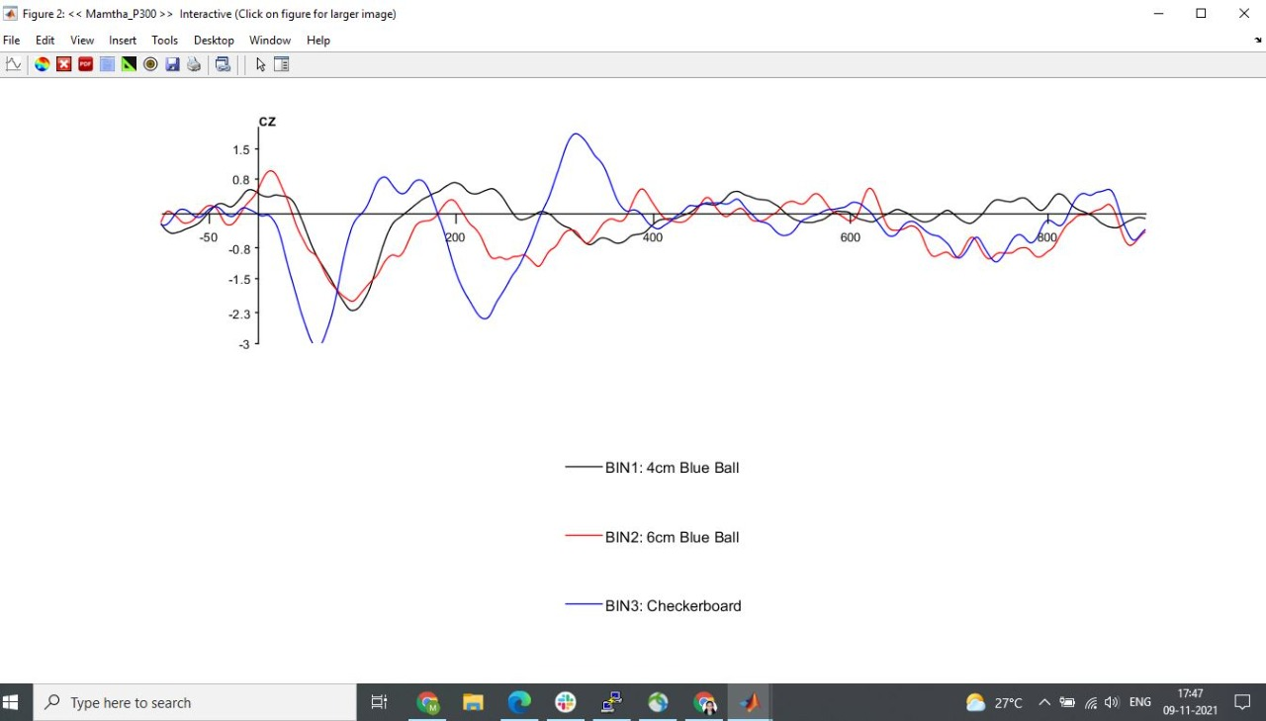

REFERENCES

[1] Polich, John. "Updating P300: an integrative theory of P3a and P3b." *Clinical neurophysiology* 118, no. 10 (2007): 2128-2148.

[2] Bulat, Matvey, Alexandra Karpman, Alina Samokhina, and Alexander Panov. "Playing a P300-based BCI VR game leads to changes in cognitive functions of healthy adults." *bioRxiv* (2020).

[3] Luck ,Stevan J . An Introduction to Event-Related Potential technique,MIT press,2014